Муниципальный этап олимпиады школьников по английскому языку 2016-2017 уч.г.

Устный тур

Комплект заданий для учащихся 4 классов

Speaking
10 points

Read the topic below carefully. You will be asked to talk about it for 1.5-2 minutes. The questions will help you. You have one minute to think about what you are going to say. You can make some notes to help you if you wish.

My Favourite Season

You should say what season you like best;
what the weather is like in the season;
what you can do in the season;
and why you like the season.

Муниципальный этап олимпиады школьников по английскому языку 2016-2017 гг.

Устный тур

Комплект заданий для учащихся 5-6 классов

Speaking
10 points

Read the topic below carefully. You will be asked to talk about it for 1.5-2 minutes. You have one minute to think about what you are going to say. Do not forget to introduce and finish your presentation. You can make some notes to help you if you wish.

Places to Take Visitors to in My Home City

Муниципальный этап всероссийской олимпиады школьников
по английскому языку в 2016-2017 учебном году
Устный тур
Говорение
7 - 8 классы

Максимально возможное кол-во баллов за конкурс Говорение-10
(Students are given the picture and they do this task together. – Students have 2 minutes to prepare (they should not speak to each other). Students have 3 minutes to talk.
Leo has decided to go on a summer ten-day tour of Portugal with his parents. Look at visual prompts, then in pairs, decide what one thing he needs to take with him and one thing he doesn’t need to take, giving reasons. You must also suggest one other thing (which is not given in the visual prompts) he can take with him.

Муниципальный этап всероссийской олимпиады школьников
по английскому языку в 2016-2017 учебном году
Устный тур
Говорение
9-11 классы

SPEAKING

STUDENT A

TASK 1

The pictures show different ways of learning about the past.
Look at the photos and think how people can learn about the happenings of the past in the world, in a country, in a family. Also, choose the two most enjoyable ways to find out about the past (1 minute).

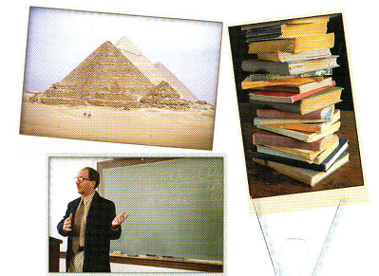

TASK 2

a) You are to speak for 1 minute on the problem in TASK 1.
Then answer 2 questions of your partner.

b) Now listen to your partner speaking on how we can learn about the past. Then ask your partner 2 questions to learn more details about the given problem.

Your answers will be recorded

Муниципальный этап всероссийской олимпиады школьников
по английскому языку в 2016-2017 учебном году
Устный тур
Говорение
9-11 классы

SPEAKING

STUDENT B

TASK 1

The pictures show different ways of learning about the past.
Look at the photos and think how people can learn about the happenings of the past in the world, in a country, in a family. Also, choose the two most enjoyable ways to find out about the past (1 minute).



TASK 2

a) Listen to your partner speaking on how we can learn about the past. Then ask your partner 2 questions to learn more details about the given problem.

b) You are to speak for 1 minute on the problem in TASK 1.
Then answer 2 questions of your partner.

Your answers will be recorded

